Zhoha Damani

**Student Id - 8730121**

Database final project

**INDEX**

|  |  |  |
| --- | --- | --- |
| **S.no** | **Particulars** | **Page No.** |
| 1 | Introduction | 1 |
| 2 | Group Work Breakdown table | 1-3 |
| 3 | Problems faced | 4 |
| 4 | Comparison and explanation between the original database with the 3NF database. | 5-6 |
| 6 | Queries (7 Assigned queries) | 10-20 |
| 7 | Queries (2 custom queries) | 21-22 |
| 8 | Conclusion | 23 |
| 9 | Appendix | 24 |

**INTRODUCTION**

The aim of this project is the development of a Music store database for the company named ‘***Soul Sound Co.***’. Our group was hired to design, develop, and test the database for the store. This database must store information of customers, their orders and singers along with their albums.

**GROUP WORK BREAKDOWN TABLE**

After the project was assigned, we prepared the group and then started dividing the work by breaking down the tasks of the project amongst the members as follows:

|  |  |
| --- | --- |
| **TASKS** | **DESCRIPTION** |
| Evaluation of the requirement | During this phase, the entire group gathered virtually and discussed what tables are required, entities in the table, and their data types.   * Done by all group members. |
| Creating ER Model | We followed the ER approach by creating a basic ER model for the database without normalization. This was performed with all members present and getting inputs from everyone.   * Done by all group members. |
| Normalization of the database | After the tables were prepared, to avoid redundancies of data, tables were fragmented to multiple different tables in order to achieve normalization.   * Done by all group members. |
| Updating of existing tables | When the normalization was under process, the team came across entities that were optional and not related much to the database, and hence those were removed and new relatable entities were updated in the table.   * Done by all group members. |
| Updating ER Model | After completing the tasks mentioned above, we updated the ER model by reverse engineering.   * Done by all group members. |
| Establishing Relationship | Updating the ER model made it easy to determine the relationships between the tables.   * Done by all group members. |
| Populating the Database | The data was populated using the insert script for each table.   * Done by all group members. |
| Preparing the queries for assigned scenarios | Understanding the requirements and making a note of possible outcomes. Breaking down the queries for easier implementation.   * Done by all group members. |
| Preparing the specific custom scenario and the query script of it. | Undertaking the individual queries, analyzing, and getting the required outcome.   * Done by all group members. |
| Word Document Preparation | The documentation was divided and the task was assigned to Zhoha, Adityakumar, and Yashkumar. |
| Preparation of presentation and the required slides to support it. | Preparing the notes of the entire process from the start of the project enabled keeping the track of activities and helped in preparing slides and the entire presentation.   * Slides made by VipulKumar and NeelKumar. * Presentation is to be done by Zhoha, YashKumar and AdityaKumar. |

**Problems faced while designing the Music Store Database:**

* Collecting the constraints and data input required to create the database.
* Designing an ideal database to avoid loss of data from the database
* Implementation to convert it into a 3rd Normal Form.
* Understanding the queries and breaking them to make them easier.

**Solution:**

* To gather the data efficiently we firstly took the prime constraint for table making the break among different group members. Hence, data collecting became easier.
* There can be a situation where deletion of data can cause loss of entire related data at times. Hence, to compensate for that we implemented Normalization.
* There are the 6 types of normalization but the most effective method to do that was found to be 3-NF. Hence, that was implemented.
* To manipulate the data in different databases is a bit difficult so we first broke the query into smaller parts, implemented the lower part of the query and further implemented the main query, and lastly implemented the concept of Join/Inner-Join/Left-Join to use multiple databases together.

**Comparison and explanation between the original database with the 3NF database:**

ER Diagram - 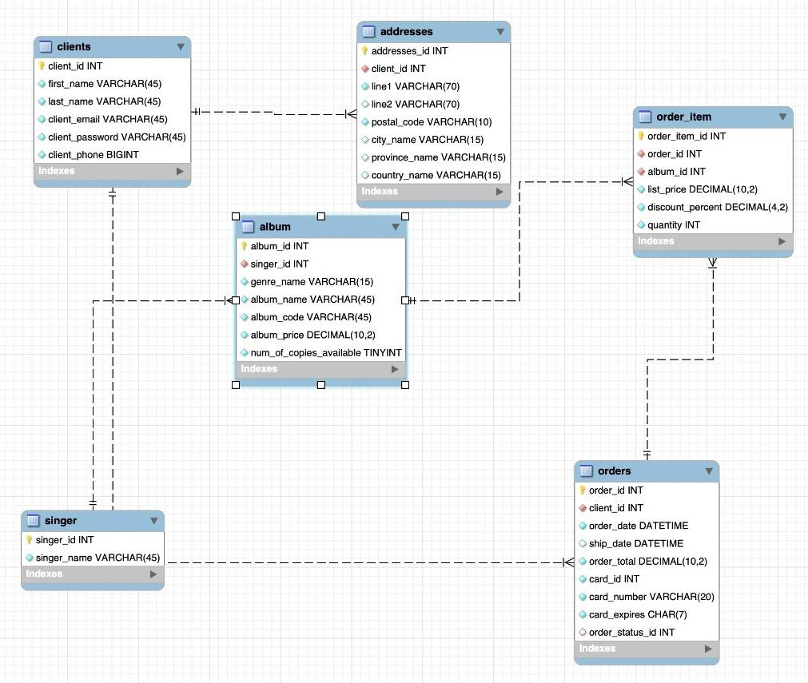

**3rd NORMAL FORM -**

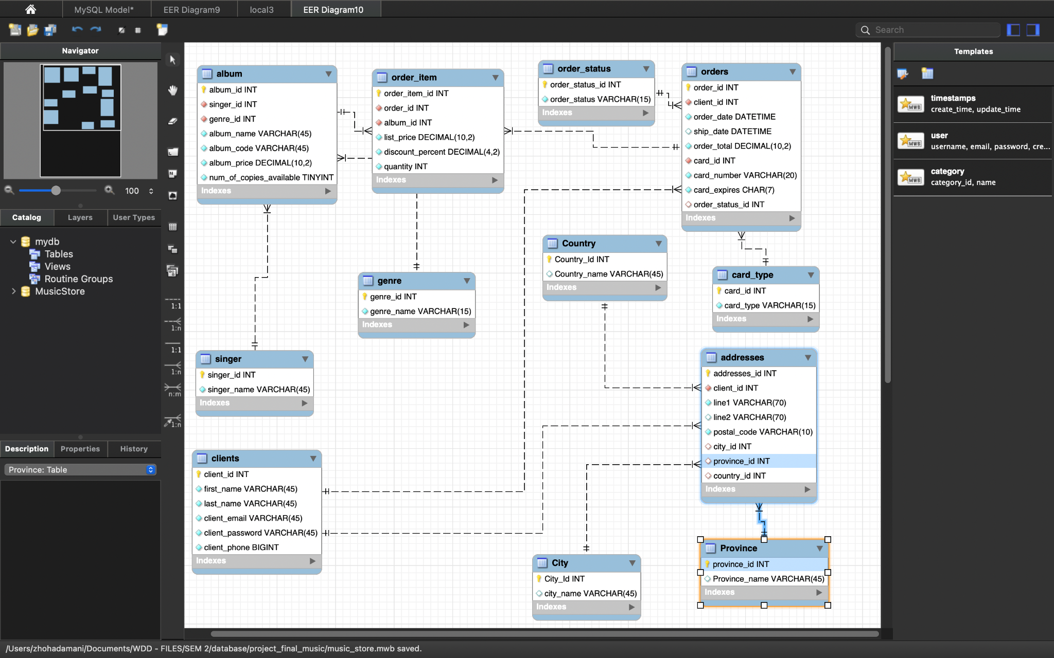

**Explanation:**

* As we can see in the first basic format of the ER diagram, we created some tables, like clients, addresses, album, order_item, singer and orders.
* As we went ahead to get our database to reach the 3rd normal form, we realised there were a lot of tables that can be created/deleted so we can reduce the amount of data duplication.
* We selected every individual table and evaluated the entities so that we can understand how we can reduce the duplication of data.
* We changed the addresses table so that we removed the country, city and province columns, which had the duplication possibility. To achieve the 3NF, we created 3 tables to store the country, city and provinces, and referenced them using the ids of the same in the addresses table.
* We changed the album table so that we removed the genre_name column, which had the duplication possibility. To achieve the 3NF, we created a genre table to store the genre_name and its id, and referenced them using the id of the same in the album table.
* We changed the order table so that we removed the order_status and card_type columns, which had the duplication possibility. To achieve the 3NF, we created 2 tables to store the order_status and card_type, and referenced them using the ids of the same in the order table.

**Advantages of 3NF:**

* Data is no more redundant.
* Data integrity is achieved.

**There are relationships between the tables as:**

* + One singer has many albums.
  + One genre has many songs.
  + One album has many songs.
  + One client has many orders.
  + One order has many order_items.
  + One address has one city, province and country.
  + One order has one card_type.

**Create queries to answer the following questions: (7 given queries )**

1. ***Display a list of clients that spent more than the average spent by clients in the past month.***

**QUERY:**

SELECT orders.client_id,

orders.order_total as client_order_total,

CONCAT(clients.first_name,' ', clients.last_name) as client_name

FROM orders

INNER JOIN clients ON clients.client_id = orders.client_id

WHERE orders.order_total >= (select

CAST(AVG(order_total)as decimal(20,2)) as average_spent from orders

WHERE order_date between '2021-03-01 00:00:00.000' AND '2021-03-30 00:00:00.000'

GROUP by orders.client_id

ORDER by average_spent DESC LIMIT 1);

**OUTPUT:**

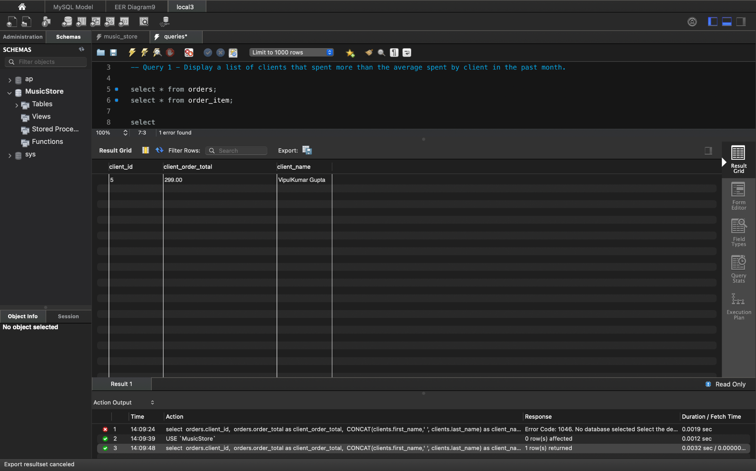

**EXPLANATION:**

* The output of this query evaluates the average spending of each client during the given time period. After this, it compares the averages of all the clients and returns the client which has spent the highest average amount in the specified time period.

***2. The top sold products and least sold products over a week.***

**QUERY:**

-- highest sold products

SELECT album.album_name,

order_item.quantity as quantity_sold

FROM order_item

INNER JOIN album ON album.album_id = order_item.album_id

INNER JOIN orders ON orders.order_id = order_item.order_id

where order_date between '2021-03-20 00:00:00.000' AND '2021-03-27 00:00:00.000'

ORDER BY quantity_sold DESC

LIMIT 1;

**OUTPUT:** *(highest sold product)*

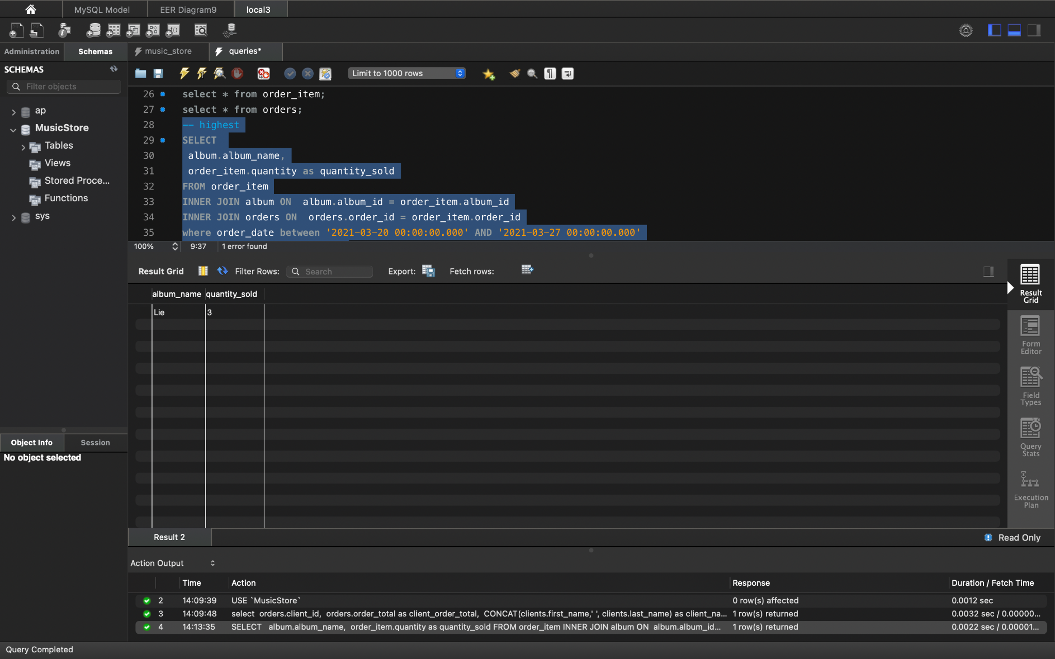

**QUERY:**

SELECT album.album_name,

order_item.quantity as quantity_sold

FROM order_item

INNER JOIN album ON album.album_id = order_item.album_id

INNER JOIN orders ON orders.order_id = order_item.order_id

where order_date between '2021-03-20 00:00:00.000' AND '2021-03-27 00:00:00.000'

ORDER BY quantity_sold LIMIT 1;

**OUTPUT**: *(lowest sold product)*

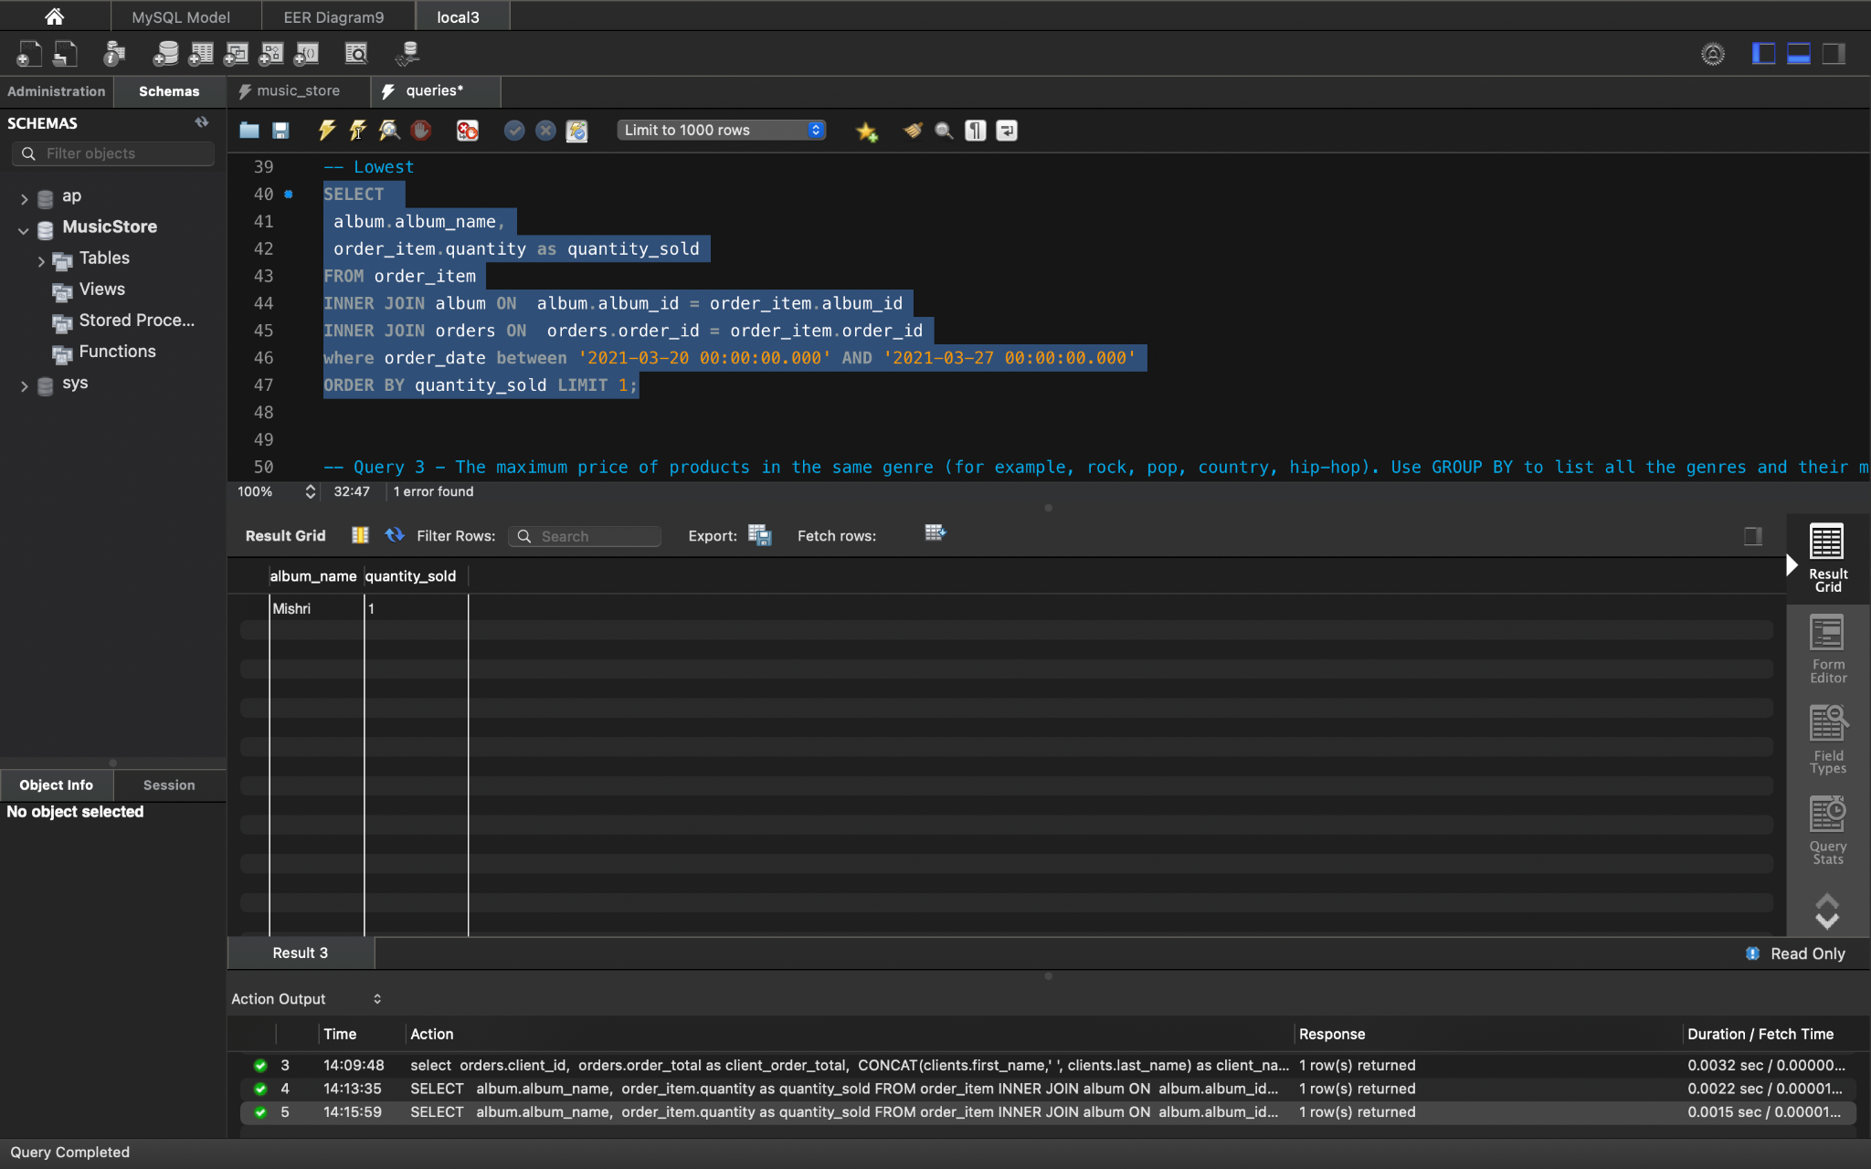

**EXPLANATION:**

* In this scenario, we have created two queries which provide the prefect output as follows:
  1. In the first query, the album is selected as output with the quantity that has the highest selling during the specified time period.
  2. In the second query, the album is selected as output with the quantity which has the lowest selling during the specified time period.

***3. The maximum price of products in the same genre (for example, rock, pop, country, hip-hop). Use GROUP BY to list all the genres and their maximum price.***

**QUERY:**

SELECT genre.genre_name,

MAX(album.album_price) as maximum_price_of_album_for_genre

FROM album

INNER JOIN genre ON album.genre_id = genre.genre_id

Group BY genre.genre_name

ORDER BY maximum_price_of_album_for_genre DESC;

**OUTPUT:**

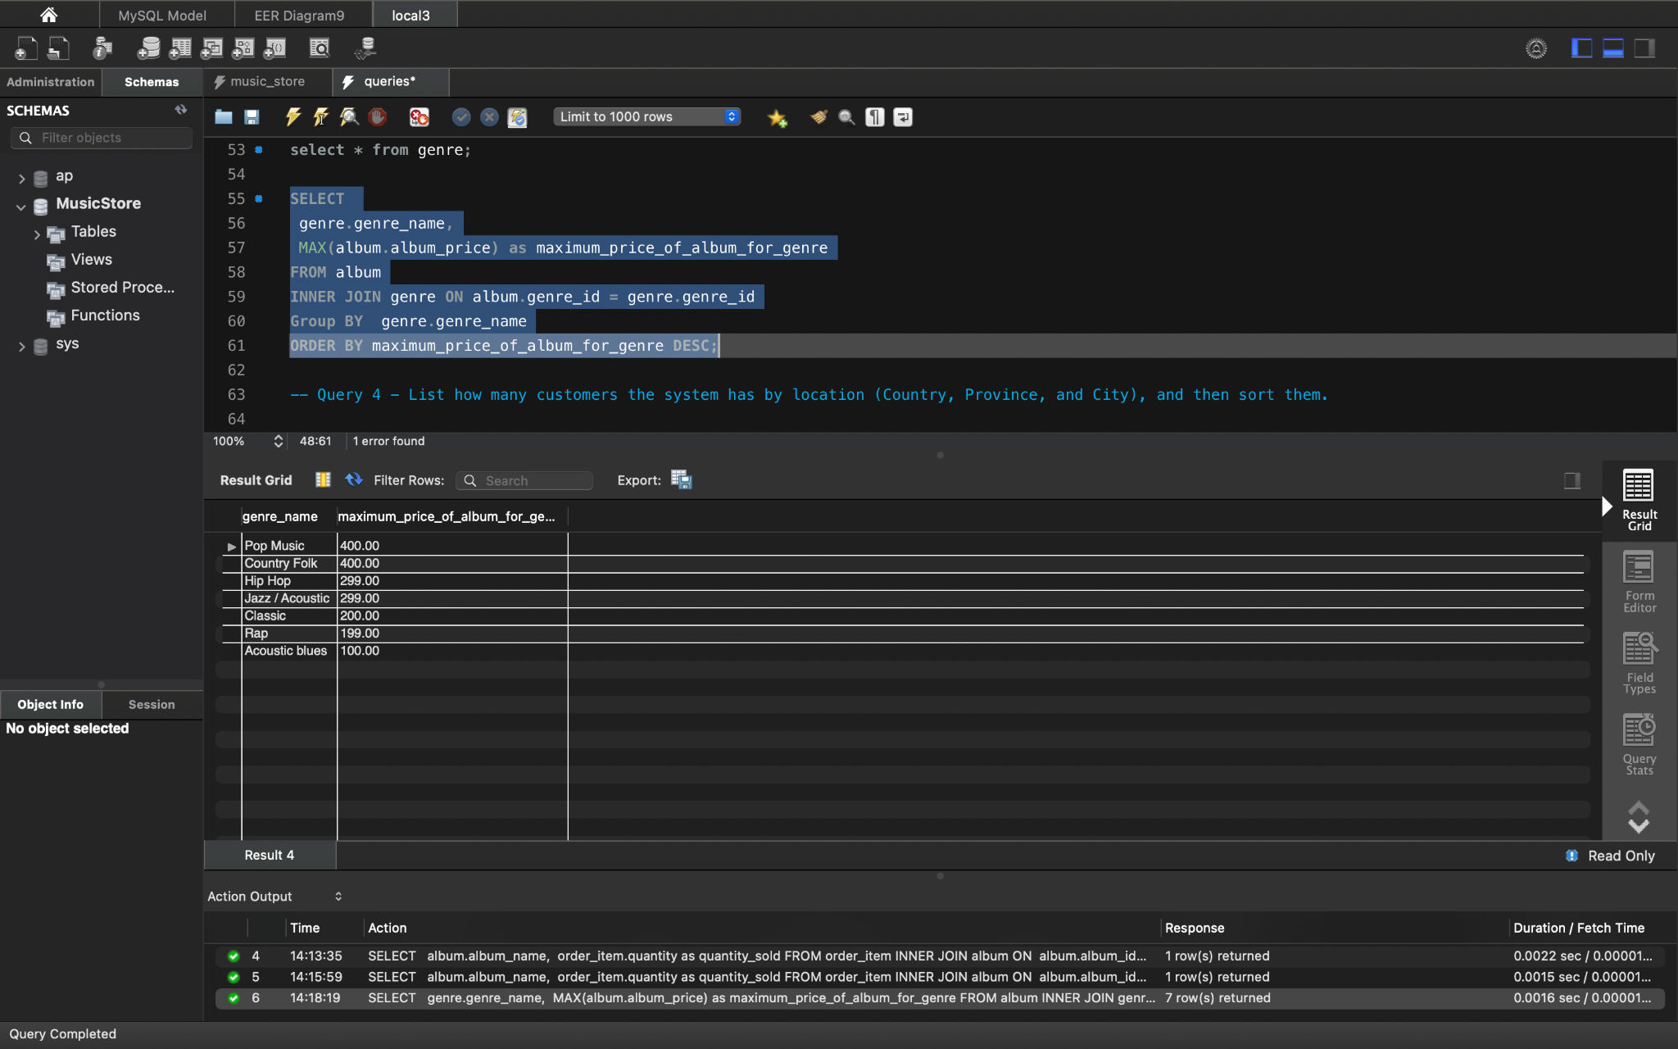

**EXPLANATION:**

* This query uses albums and joins it with genre table to display the album name which has the maximum price in a specific genre.

***4.List how many customers the system has by location (Country, Province, and City), and then sort them.***

**QUERY:**

SELECT cou.country_name as country_Name, p.province_name as province_Name, c.City_name ,count(c.city_name) as count_Clients

FROM (clients cl JOIN addresses ad ON cl.client_id = ad.client_id)

JOIN City c ON ad.city_id = c.City_id

JOIN province p ON ad.province_id = p.province_id

JOIN country cou ON ad.country_id = cou.country_id

GROUP BY c.City_name, province_Name, country_Name;

**OUTPUT:**

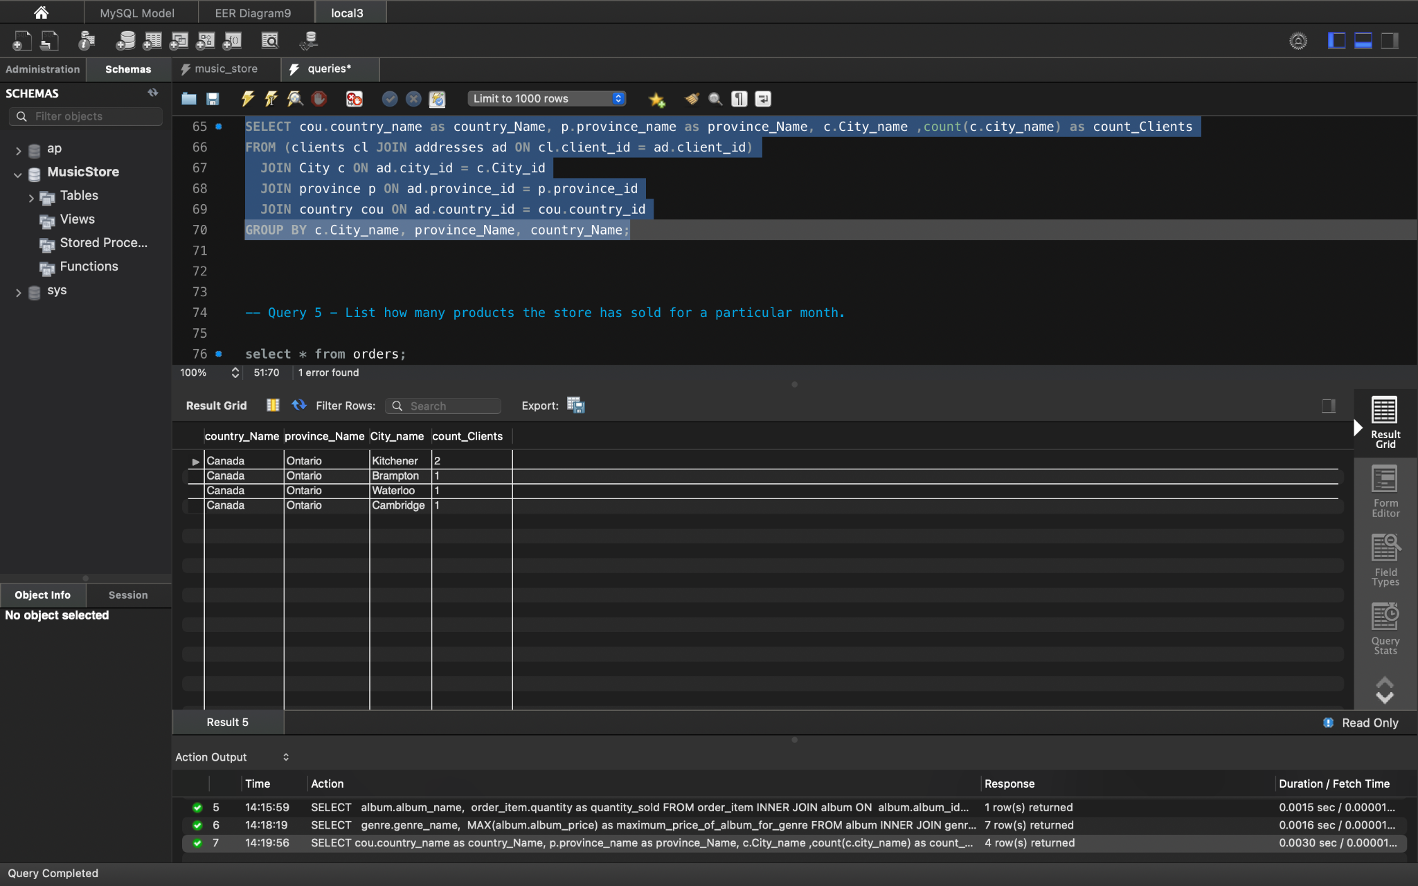

**EXPLANATION:**

* In this scenario, the query is returns the information of clients based on their location and groups the location showing the number of client a specific location has.

***5. List how many products the store has sold for a particular month.***

**QUERY:**

select count(quantity) as product_sold_in_march_month

from order_item

INNER JOIN orders ON orders.order_id = order_item.order_id

where order_date between '2021-03-01 00:00:00.000' AND '2021-03-30 00:00:00.000';

**OUTPUT:**

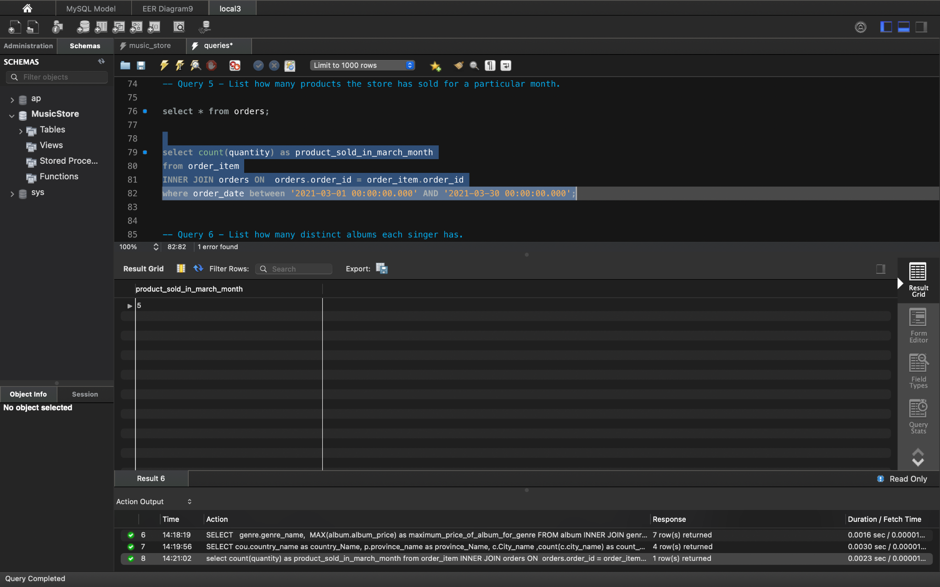

**EXPLANATION:**

* This scenario requires finding the number of total items the store sold in the given month. Here, the month selected is March and we have specified the time period by selecting the range of date.

***6. List how many distinct albums each singer has.***

**QUERY:**

SELECT DISTINCT

singer.singer_name as Singer_Name,

COUNT(album.singer_id) as count_of_albums

FROM album

INNER JOIN singer ON singer.singer_id = album.singer_id

GROUP BY album.singer_id, singer.singer_name

ORDER BY Singer_Name;

**OUTPUT:**

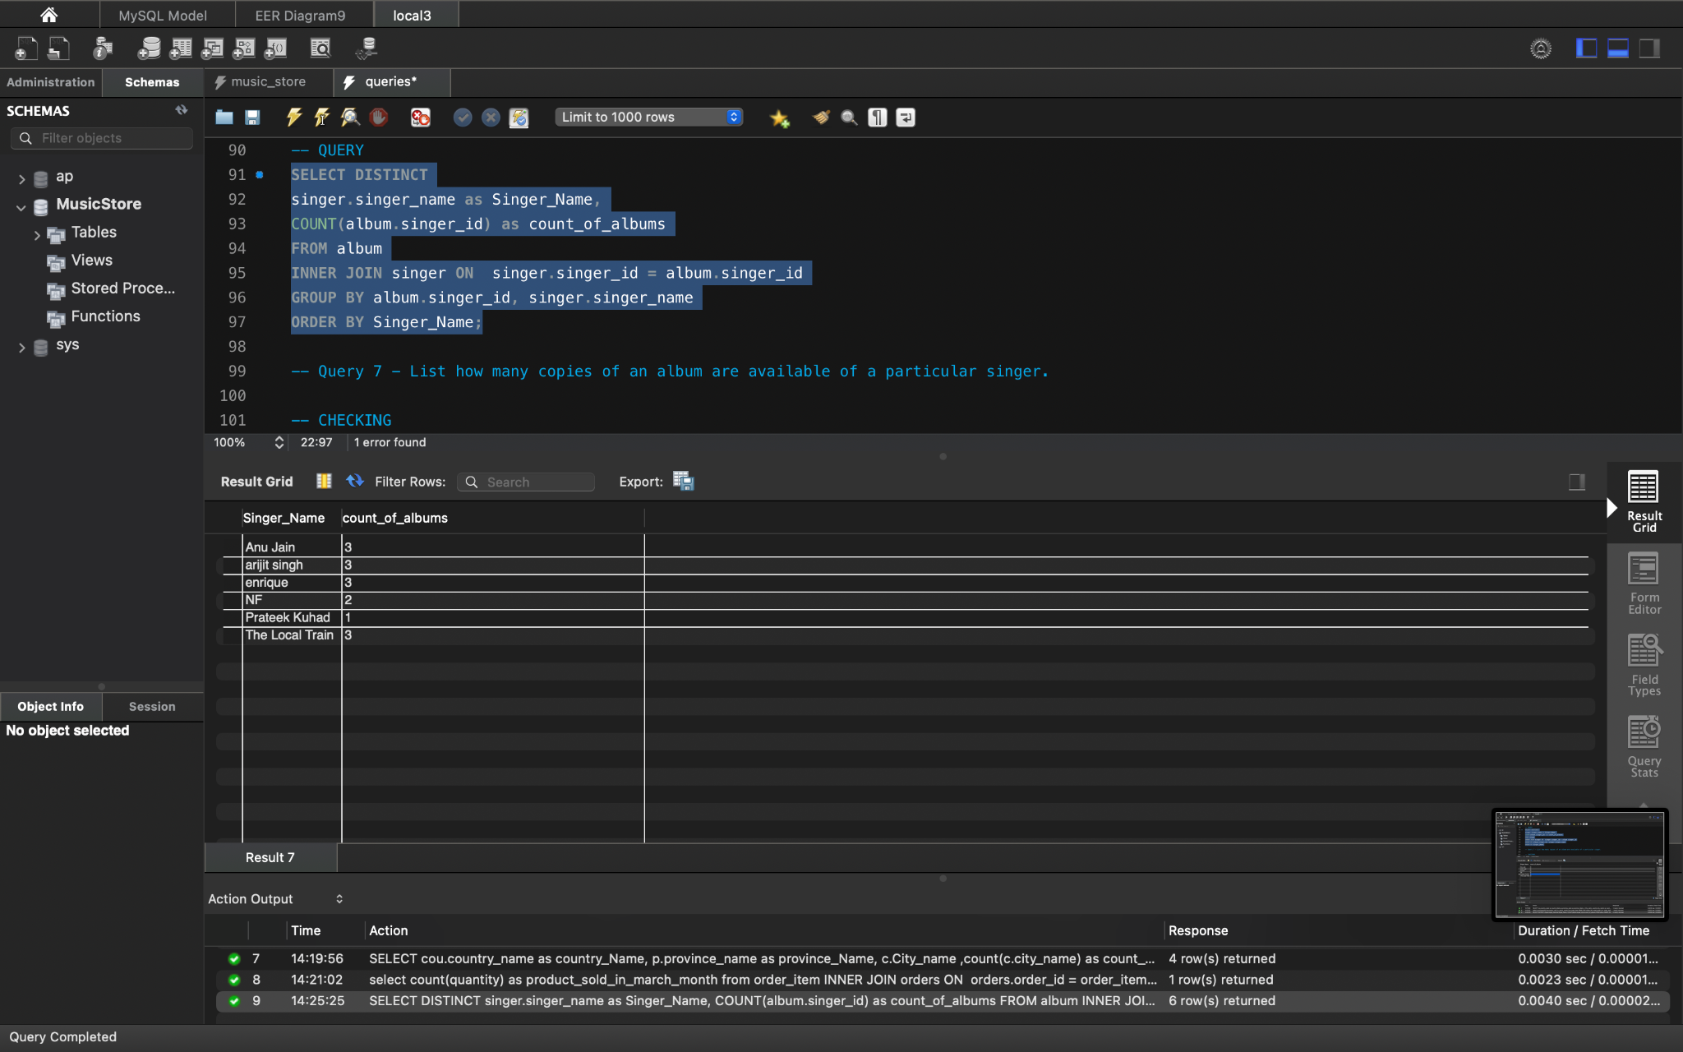

**EXPLANATION:**

* In this scenario, we have to join two tables namely: albums and singer. It fetches the data from both the tables and using inner join to join the output showing how many distinct(different) albums each singer has.

***7. List how many copies of an album are available of a particular singer.***

**QUERY**:

SELECT

singer.singer_name,

album.album_name,

(CASE WHEN order_item.quantity > 0

then (album.num_of_copies_available - order_item.quantity )

else (album.num_of_copies_available)

END)

as copies_available

FROM album

INNER JOIN singer ON singer.singer_id = album.singer_id

left JOIN order_item ON album.album_id = order_item.album_id;

**OUTPUT:**

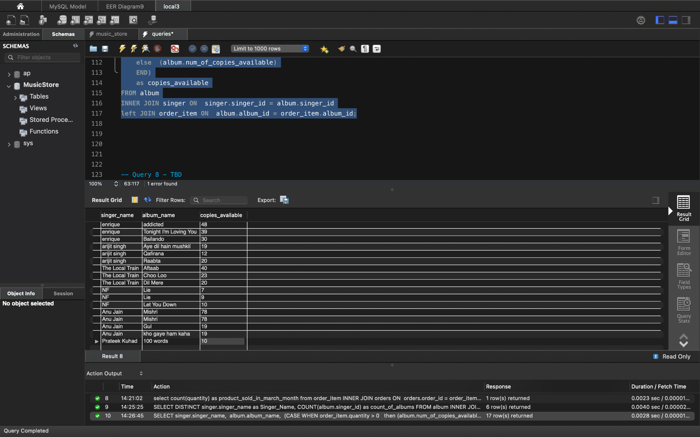

**EXPLANATION:**

* In this scenario, the requirement is to display the available quantity of the albums per artist. In order to achieve that, the query is required to join singer, album tables and for calculating the remaining quantity it uses the order and album tables. Here, we had to use the CASE statement in the calculation part.

**Create queries to answer the following questions: (2 new queries)**

1. Find out whether delivery is on time or late, and display number of days taken to ship product from the time of order

**QUERY:**

SELECT

order_id,

CAST(orders.order_date AS DATE) as ordered_date,

CAST(orders.ship_date AS DATE) as shipped_date,

DATEDIFF(ship_date,order_date) as days_taken_to_deliver,

CASE

WHEN DATEDIFF(ship_date,order_date) < 8

THEN 'DELIVERY IS ON TIME'

ELSE 'DELIVERY IS LATE'

END shipment

FROM

orders

WHERE

ship_date IS NOT NULL

ORDER BY

order_date;

**OUTPUT:**

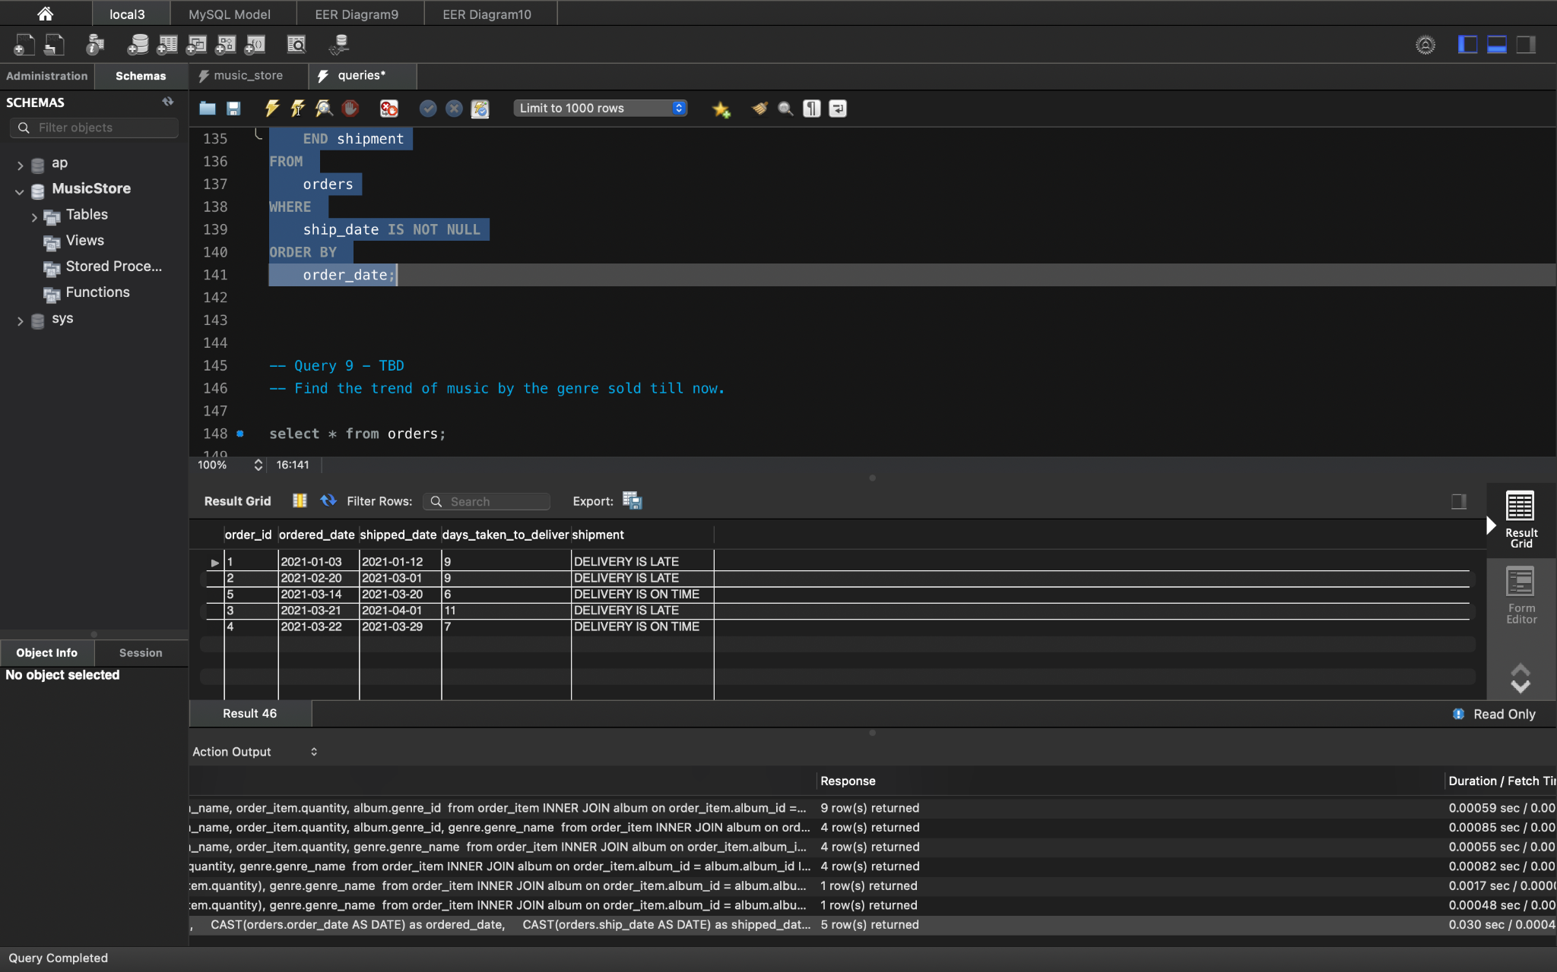

1. **Find the trend of music by the genre sold till now.**

**QUERY:**

select max(order_item.quantity),

genre.genre_name

from order_item

INNER JOIN album on order_item.album_id = album.album_id

INNER JOIN genre on album.album_id = genre.genre_id;

**OUTPUT:**

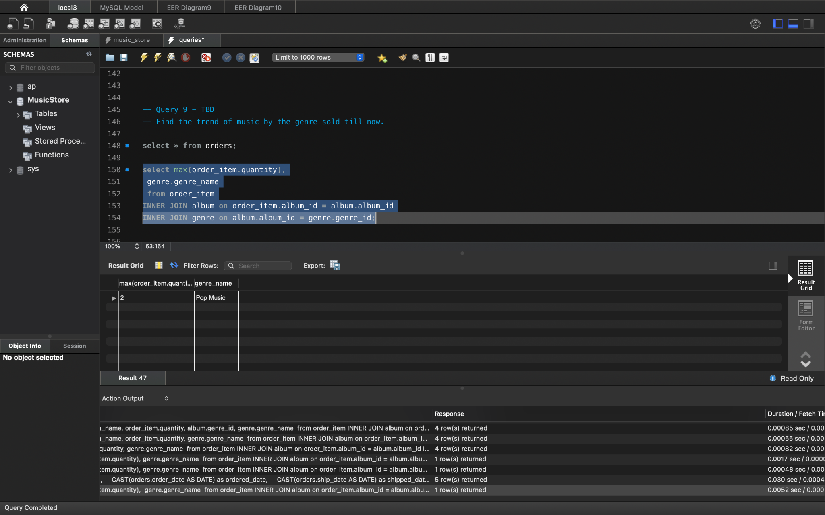

**CONCLUSION**

The music store database project is a great opportunity for us to test our database knowledge as it helps us to implement different concepts of database design data, from creating tables to using the EER model and performing operations. We also learned how database systems work in real life.

**APPENDIX**

1. ***Orders table***

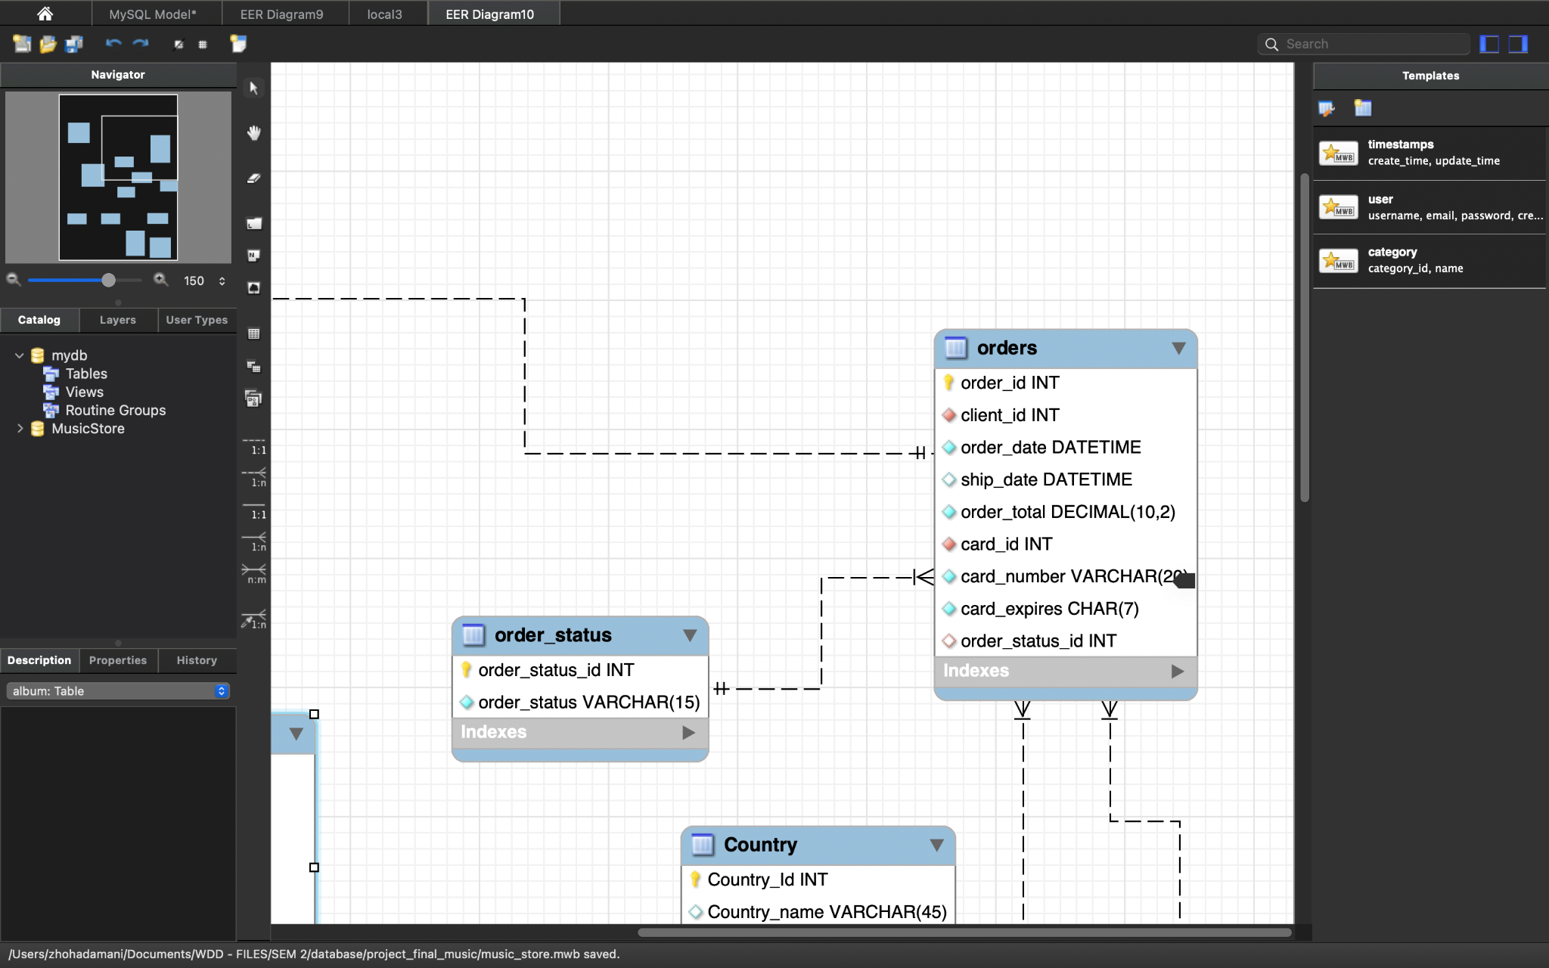

***Explanation:***

* The orders table has 9 columns.
* The order_id field is a unique numeric identifier for the order.
* The client_id references the client_id from the client’s table to get the client details. It has the datatype integer.
* Order_date is used to specify the date; the order was placed.
* Ship_date is used to specify the date; the order was shipped.
* Order_total is the total of the products/ albums that a client has purchased in one order.
* Card_id is the card id that references the card_type table which was created to avoid data duplication.
* Card_number is the number entered by the user of the card during the order transaction.
* Card_expires is the expiry date of the card used in the transaction.
* Order_status_id is the id that references the order status table to get the status of the order in question.

1. ***Order_item table***

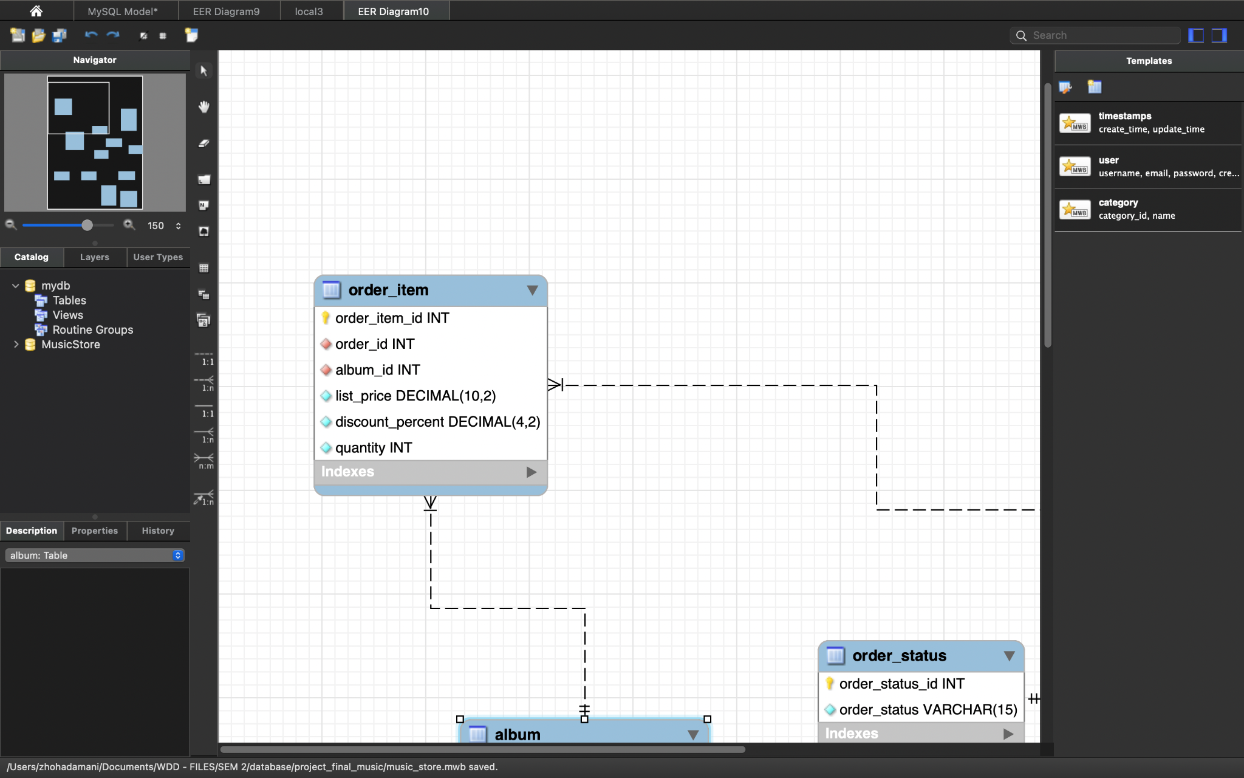

***Explanation:***

* order_item_id is used to identify unique order items, it is the primary key in this table.
* Order_id is used to reference the order_id from the order table to get the order details.
* album_id is used to reference the album_id from the order table to get the order details.
* List_price is the price of the album
* Discount_percent is the percentage of discount on the order that the client got.
* Quantity is the quantity of the album in the order. The datatype used is integer.